**BART Rider Commuter Patterns**

Kenneth Ceglia

Colorado State University Global

Course Code: MIS581

Instructor Dr. Ford

Due Date 4/18/2021

**BART Rider Commuter Patterns**

People form patterns. Patterns are seen in almost every aspect of daily life. Many people wake at the same hour, leave for work and follow the same path each day to and from work. This is not entirely uncommon with other communities. Bees travel the same paths to and from their hive, ants seek out and establish new, repeatable paths. In larger cities with extensive public transportation networks, such as BART or “Bay Area Rapid Transit” many people commute on the same route lines each and every day, with surprisingly regularity.

The rapid transit system in the Bay Area of California has approximately 50 stations (expanding regularly) and 8 major lines. Close to half a million people ride BART every day through a network of over 2500 different combinations of stations. Predicting where riders are heading each day opens the door to improved rider services, improved health conditions and new revenue streams through direct to rider marketing and advertisements. Knowing when and where riders are traveling provides enhanced opportunities for local business to advertise services and offerings directly to consumers with predictable regularity and time exposure.

**Objectives**

The focus or objectives of this research is determining if route patterns are discoverable, repeatable and predictable and if these patterns provide opportunities for rider and local business services. There are several different types of patterns in this study.

When looking at ridership in a given rail or subway system, there are several levels or granularities to consider. On one end is total ridership. How many riders are using the rail system? Knowing if total ridership is changing is particularly important for the BART system itself. For example, knowing if total ridership is increasing or decreasing can direct focus towards improved rider services, such as more trains or better schedules. Total ridership over time is also useful in understanding seasonal fluctuations, such as more riders in the winter months over summer months. Transportation services may use this information to offer increased services during up cycles and possibly decrease services or possibly add incentives to encourage more riders in down seasons.

The next level considers ridership at individual stations. For example, knowing the total number of riders that queue at a single station each day provides a more targeted objective. Further, knowing how many riders queue at a station each hour provides a finer detail for rider services. Further yet, knowing the number of riders departing a station and the distribution of riders to their destinations provides extremely high-fidelity detail of ridership patterns. Services may be offered that are targeted for the distribution (and number) of riders heading for a known destination. This detail provides local business the opportunity to offer goods and services to a predictable number of patrons arriving by their local businesses, even at a given hour of the day. Services or marketing may be offered at the departing station and continued in transit (on train) knowing confidently the number of riders and duration to their arrival station.

The objective of this research is to discover the ridership patterns that focus on high level and detailed route patterns over time and the predictability of those patterns that can be used by BART services, local businesses and improved health and sanitation services.

# **Overview of Study**

BART is an advanced public transportation network that links communities in the San Francisco Peninsula with cities in the East and South Bay as far south as Millbrae and as north as Richmond. BART has been in operation for over 45 years carrying citizens to and from work, universities and colleges, special and sporting events. BART runs on all electric cars with the majority of power (95%) coming from renewable energy sources making BART one of the most environmentally successful public transportation systems in the world (*Sustainability*, n.d.).

Like any service, BART faces competition and demands for improved services. Over the last few years (prior to Covid-19) ridership has declined due to crowded trains, security and sanitation concerns. Riders expect more services, better schedules and improvements to stay on board. One of the ways to improve BART is to better understand who, when and how it is being used.

The goal of this study is to analyze ridership route patterns to provide analytics that can be used to improve the lives and services of BART riders and local businesses (Wang et al., 2019). By understanding and predicting the ridership profiles, BART and local businesses can offer improved services to attract new riders and retain existing ones (Andrews et al., 2016).

# **Research Hypothesis**

*BART Riders follow the same and predictable network route patterns for each day and hour that can be used to improve services, direct local businesses advertisements and increased rider safety*.

**RQ1**: Is the number of riders in queue at a station related to the day of week and time of day?

$$H_{O}1:Rider {queue}_{{time}_{i}, {day}_{i}}=Rider {queue}_{{time}_{j}, {day}_{j}} for any i,k$$

$$H_{A}1:Rider {queue}_{{time}_{i}, {day}_{i}}≠Rider {queue}_{{time}_{j}, {day}_{j}} for any i,k$$

The NULL hypothesis is that the day and hour have no effect on the queue of riders for a station. The alternative is that the day and time do have an effect on the number of riders in queue for a given station.

**RQ2**: Do the same proportion of riders **depart** for the same stations each day for morning commutes for a given day of the week?

$H_{0}2$: $\left(\begin{matrix}{Riders}_{{day}_{k}{hour}_{j}} & at & {Station}_{i} \\ ⋮ & … & ⋮ \\ {Riders}_{{day}_{k}{hour}_{j}} & at & {Station}_{n}\end{matrix}\right)$ = $\left(\begin{matrix}{Riders}_{{day}_{j}{hour}_{j}} & at & {Station}_{i} \\ ⋮ & … & ⋮ \\ {Riders}_{{day}_{j}{hour}_{j}} & at & {Station}_{n}\end{matrix}\right)$

$$H_{A }2: The proportion of riders traveling the same route are not the same$$

They NULL hypothesis is for any day of the week, such as Monday or Friday, that the proportion of riders that go to the same station each morning is the same.

### 

**RQ3**: Do the same proportion of riders ***arrive*** at the same stations each day for morning commutes for a given day of the week?

$H_{0}3$: $\left(\begin{matrix}{Riders}_{{day}_{k}{hour}_{j}} & at & {Station}_{i} \\ ⋮ & … & ⋮ \\ {Riders}_{{day}_{k}{hour}_{j}} & at & {Station}_{n}\end{matrix}\right)$ = $\left(\begin{matrix}{Riders}_{{day}_{j}{hour}_{j}} & at & {Station}_{i} \\ ⋮ & … & ⋮ \\ {Riders}_{{day}_{j}{hour}_{j}} & at & {Station}_{n}\end{matrix}\right)$

$$H_{A }3: The proportion of riders traveling the same route are not the same$$

They NULL hypothesis is for any day of the week, such as Monday or Friday, that the proportion of riders that go to the same station each morning is the same. The NULL hypothesis is that riders are from the same population of commuters.

**RQ4**: Has the total number of BART riders decreased in recent years?

$$H_{0}4: B_{1}=0$$

$$H_{A}4: B_{1}<0$$

The NULL hypothesis indicates the number of riders has remained the same, or a regression fit indicates the slope is constant. The alternative is the regression slope is negative, indicating ridership has decreased. Note: This is assuming a linear fit, it may end up an exponential or quadratic fit, where ridership may have increased, then decreased recently. In this case, either a piece-wise linear may make sense, or simply test a negative quadratic coefficient.

# **Research Design**

The following discusses the research methodology and how the study is conducted start to finish, the logic and sampling methods used. Included in the research design is the methods used, which specify how the data is collected and processes followed by statistical tests used to validate or disprove hypothesis that riders are predictable

## **Methodology**

This primary analysis is quantitative. The Ridership data, schedules and trip times required for the study are exclusively numeric. The analysis for this study is quantitative, using classical statistics methods to test hypothesis, and provide predictive outcomes. Machine learning approaches may be used as well for predictive responses. Below looks at the methodology used throughout the study to validate (or reject) the hypothesis that rider routes are determined by the day of week and hour of day and travel in repeatable routes.

**Process Flow**

The methodology flow starts with data extraction, data reduction, exploration. These three steps are mostly linear with some iterations between reduction and exploration. Following are hypothesis testing.

**Logic**

The research type used is a basic research framework that uses a deductive approach to test the theory that riders following predicable route patterns based on day and hour. There is a an inductive element that seeks to discover the highest traffic routes and select high volume stations and well-traveled routes. Not all routes are traveled extensively with large ridership. There are likely routes with very small riders and no correlations or predictable behavior. These are also important to observe, however this study focuses on high volume and serviced routes.

**Sampling**

Secondary sampling is used. The samples used are sourced from BART Open Data Site where the data has already been collected. This has some implications when testing – specifically for route proportion comparisons using a c chi square test for homogeneity. These tests assume data has come from the same population. For this study, that is the assumption, but unproven or verified. It is assumed the same population is riding BART each day with occasional exceptions.

**Methods**

Quantitative analysis is the primary method used. The study focuses on ridership data and rail schedules, which in both cases are exclusively numeric. The data samples are provided by BART open data sources and contained in several individual CSV formatted files. Quantitative data is provided in multiple resolutions over several tables. Schedule data is provided through HTTP interface from BART Open Data Initiative.

**Ridership Data**

BART provides Entry/Exit data for each year starting in 2013 through 2021 which includes every rider’s departure and arrival station summarized per hour. This data set includes every rider’s entry and exit station pair over the last eight years.

Note: *Since trip times are dynamic per time of day, and trip times for historical ridership data is not provided, trip times were estimated using current schedules “averaged” over each day and hour.*

*Additionally, holidays or other occasions that represent outlier events are removed from sampling.*

# **Analysis**

The BART network currently operates 50 stations, on eight lines. This equates to about 2500 routes passengers can take. Some routes are naturally more travelled than others. The focus of the study will target 2019 as this is the most recent year prior to Covid-19. Covid-19 heavily influenced and altered the current ridership levels substantially.

**Descriptive**

To focus the analysis, the BART top level network is observed for the most common routes and commute hours where a departure and arrival station route is selected from the *Antioch-SFIA* line. The *Antioch-SFIA* line was selected to limit the initial exploration. Figure 1 shows the total riders ***departing*** for the morning commute at each station, and figure 2 shows the total riders ***arriving*** at each station.

Figure 1

Total Riders departing, morning commute

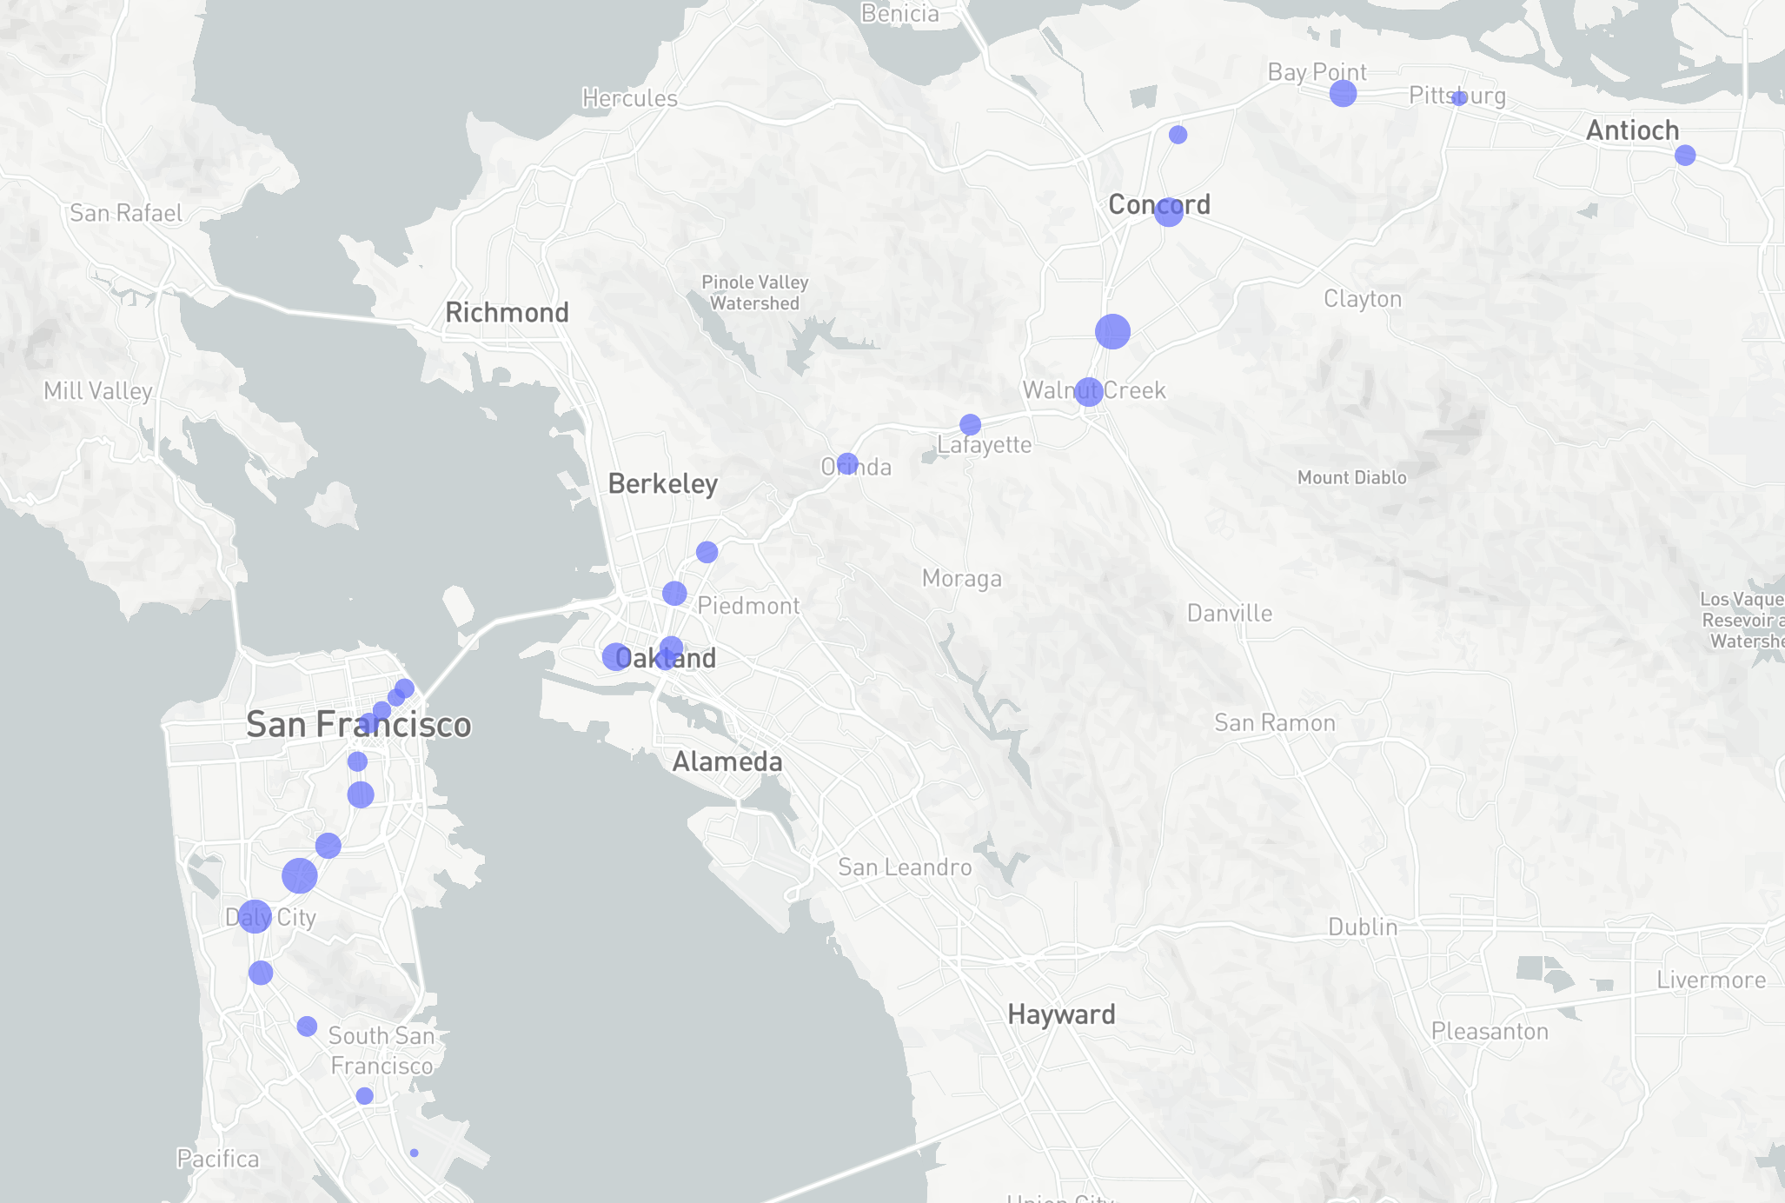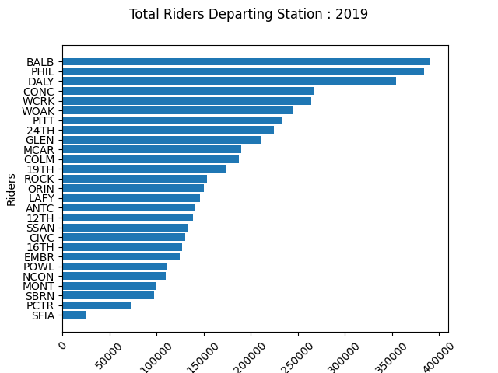

Note: map generated by © Mapbox, © OpenStreetMap

Figure 2

Total riders, arriving morning commute

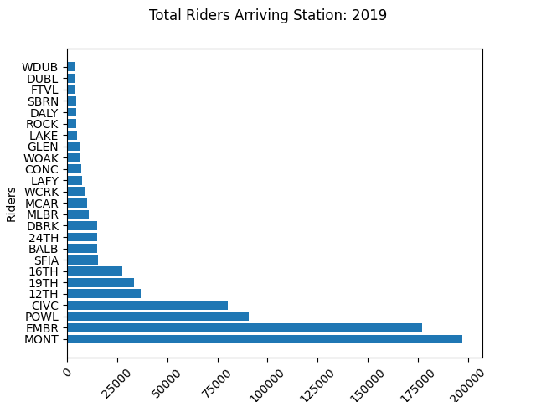

Note: map generated by © Mapbox, © OpenStreetMap

Figure 3

Total riders by hour and day for 2019

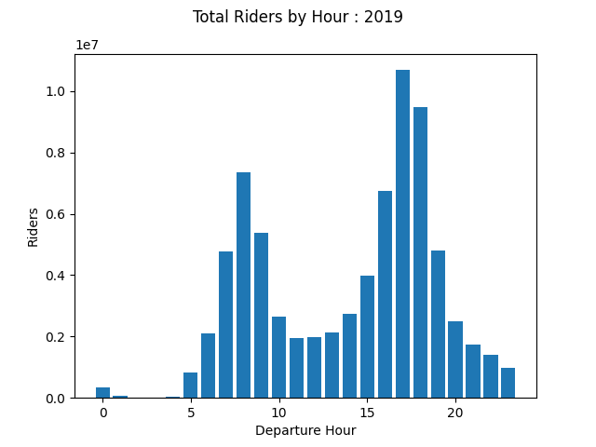

From the map overlays in Figures 1 and 2, departure stations Concord, Pittsburgh and Pleasant Hill heading are good destinations stations with high rider levels. Arrival cities such as 12th street and Daly City are good choices as they represent commonly traveled routes with high commuter sizes at peak AM hours. From Figure 3, the total riders over the year show peaks in the AM and PM commutes, and total riders for each day of the week peak on Tuesday. This gives a good description of the ridership profile over the BART network.

**RQ1**: Is the number of riders in queue at a station related to the day of week and time of day?

$$H_{O}1:Rider {queue}_{{time}_{i}, {day}_{i}}=Rider {queue}_{{time}_{j}, {day}_{j}} for any i,k$$

$$H_{A}1:Rider {queue}_{{time}_{i}, {day}_{i}}≠Rider {queue}_{{time}_{j}, {day}_{j}} for any i,k$$

The first hypothesis asks if total riders queuing for a given station are dependent on the hour and day of the week. The NULL hypothesis is that all riders are from the same population of commuters following the same consistent routes. This gives two independent variables, ***time and day*** of ***day of week*** (Monday, Tues, Wed…) and a single dependent Rider count. Figure 4 shows the mean riders broken down by hour for the Concord Station. Figure 5 shows the mean riders for each day of the week.

Figure 4

Average riders departing the Concord Station by hour

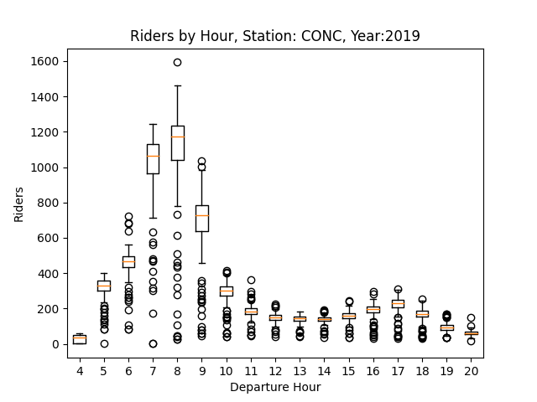

Figure 5

Average Riders departing the Concord station by day of week

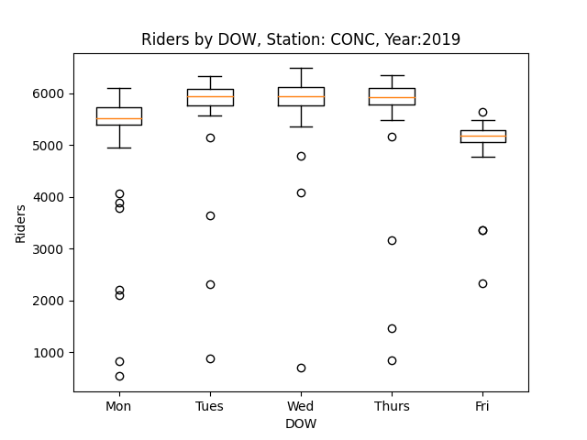

The mean riders per hour is clearly peaked between 7:00 to 8:00am, which is expected for the morning commute. The mean riders per day of the week appears slightly differentiated where Fridays and Mondays are the lowest ridership on average, and Tuesday through Thursday as heavy days. Both distributions show tight variances with some outliers mostly on the lower ends of each hour or day of week. (Note, *the ridership over the days of week appears to have a cyclic pattern, that likely repeats each week*).

To test the hypothesis that riders are different per hour and day of week, a two-way ANOVA is run against the riders over 2019 with departure hour and day of week as independent factors.

Figure 6

Two-way ANOVA for Rider totals by hour, by day of week

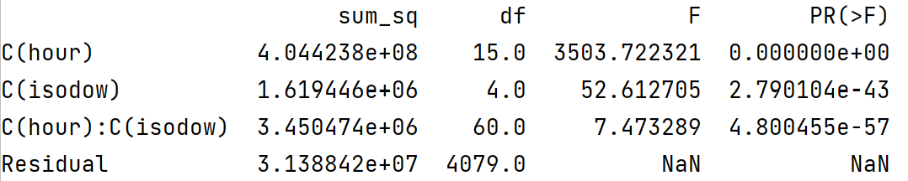

The two-way ANOVA p-value is less 0.05 alpha level, rejecting the NULL hypothesis that the riders per hour and day are equal. The alternative hypothesis is accepted that the mean ridership is independent per hour and day.

Now that ridership is established as independent per hour and day of the week, the root cause or reason for the variance is explored. The results of the two-way ANOVA test show independence, but not the cause or explanation. The differences per hour are very clear, but the differences per day are less so. To explore those differences, the ridership below is viewed as a ***time series*** to explain daily variation, such as any trending and/or seasonal or periodic components. The total riders per day over the year is shown below in figure 7, along with the Fourier transform in Figure 8 of the riders per day. The time series shows a clear cycle, and the Fourier transform shows a dominant peak at approximately 52, which indicates a weekly cycle.

Figure 7

Daily riders for Concord station over 2019 with 2x-standard deviation bars

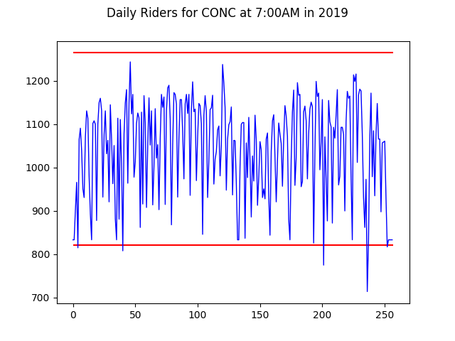

Figure 8

Fourier transform of daily riders for Concord 2019

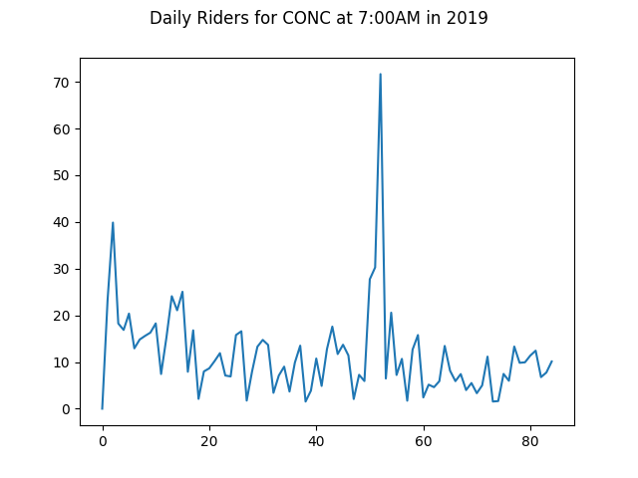

Before verifying and testing the periodicity, the ridership time series should be stationary. An Augmented Dickey-Fuller test is run to validate a stationary series.

$$H_{O}1b:Ridership is non-stationary$$

$$H_{A}1b:Ridership is stationary$$

The Augmented Dickey-Fuller test results in figure 9, show a p-value of less than 0.05

Figure 9

Output, augmented Dickey-Fully test for stationarity

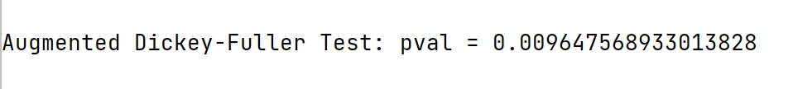

Rejecting the null hypothesis that the rider per day are non-stationary over time. With a stationary time series, the next hypothesis if riders are periodic every week as observed in the data can be validated. The following hypothesis checks for periodicity in ridership levels.

$$H_{O}1c:Ridership is not weekly periodic$$

$$H_{A}1c:Ridership is weely periodic$$

Figure 10 and 11 below, show the time series decomposition and auto correlation respectively. Both show significant periodicity at five days or weekly.

Figure 10

Trend and seasonal decomposition for Daily Concord riders

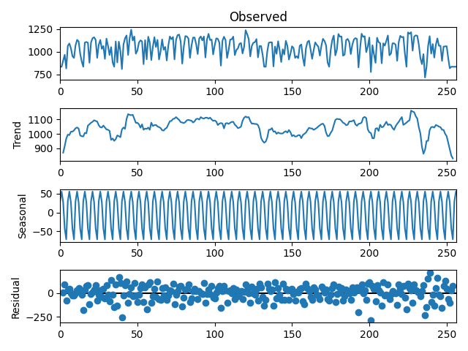

Figure 11

Autocorrelation for Concord daily riders

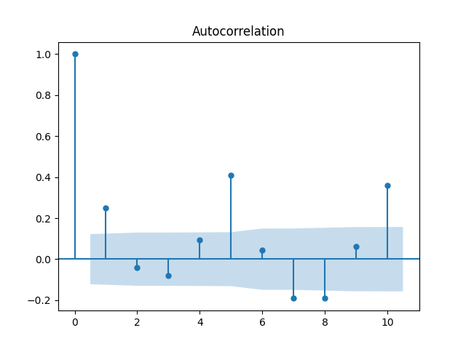

The seasonal decomposition plot shows an observed period each five days or weekly, which about a 100 rider peak to peak change per day. This is also consistent with the Fourier analysis, which shows a peak to peak at 52 weeks of approximately 80+/- riders. The autocorrelation plot shows a peak at five and 10 (and would repeat each five days), above the 95% confidence limits using Bartlett’s formula.

This further explains the variance and two-way ANOVA by indicating that riders are cyclical per week and queue between 7:00 and 8:00AM as the most impacted hours.

**RQ2**: Do the same proportion of riders go to the same stations each day for morning commutes for a given day of the week?

$H_{0}2$: $\left(\begin{matrix}{Riders}_{{day}_{k}{hour}_{k}} & at & {Station}_{i} \\ ⋮ & … & ⋮ \\ {Riders}_{{day}_{k}{hour}_{k}} & at & {Station}_{n}\end{matrix}\right)$ = $\left(\begin{matrix}{Riders}_{{day}_{j}{hour}_{k}} & at & {Station}_{i} \\ ⋮ & … & ⋮ \\ {Riders}_{{day}_{j}{hour}_{k}} & at & {Station}_{n}\end{matrix}\right)$

$$H_{A }2: The proportion of riders traveling the same route are not the same$$

This hypothesis is critical to the overall assumption that rider travel in predictable patterns. This hypothesis looks at where riders travel to each morning.

To test the hypothesis, the Concord station is looked at for Tuesday commutes (Tuesday being a heavy commuter day established above) and the set of (source-destination) routes are tabulated with total riders for day departing at 7:00AM. To test the hypothesis, the chi-square test for homogeneity is used to determine if riders follow the same routes and in the same proportions each morning. For example, do 20% of riders head to Embarcadero and 30% to the Civic Center and so on each morning, regardless of the total number of riders. Are the routes and proportion of riders the same each day?

The runs for each day through the 2019 are used for the Concord station. From figure 12, a dominant proportion of riders are observed following the same route patterns each day as proportions. Figures 13 show the routes plotted over time to observe any differences in route proportions. Both figures show very little variance in proportions giving strong indication that the routes are consistent.

Figure 12

Routes from Concord station over 2019 overlaid



Figure 13

Routes from Concord station over 2019 plotted over time



To test the hypothesis that routes each day are from the same population and proportions, the chi-square test for homogeneity is used.

Figure 14

Chi-square test for homogeneity

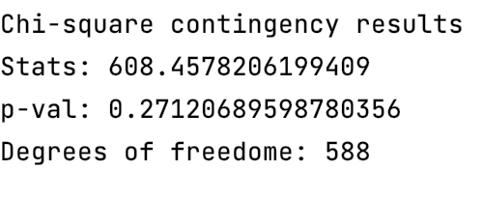

The chi-square test for homogeneity produced a p-value of 0.522, which fails to reject the NULL hypothesis, that all rider routes are from the same populations of riders traveling each day over the course of 2019. This is a remarkable result, showing surprising consistency in how riders commute each day.

(Note: *Selected days are removed that represent outliers, such as holidays or special events. 1 day in total was identified as an outliers and removed*)

**RQ3**: Do the same proportion of riders arrive from the same stations each day for morning commutes for a given day of the week?

$H_{0}3$: $\left(\begin{matrix}{Riders}_{{day}_{k}{hour}_{k}} & at & {Station}_{i} \\ ⋮ & … & ⋮ \\ {Riders}_{{day}_{k}{hour}_{k}} & at & {Station}_{n}\end{matrix}\right)$ = $\left(\begin{matrix}{Riders}_{{day}_{j}{hour}_{k}} & at & {Station}_{i} \\ ⋮ & … & ⋮ \\ {Riders}_{{day}_{j}{hour}_{k}} & at & {Station}_{n}\end{matrix}\right)$

$$H_{A }3: The proportion of riders traveling the same route are not the same$$

The second test to consider is the “***arriving***” route. This is where the routes are model by looking at riders arriving to a given station. This is essentially the opposite of RQ2, where the routes of departing riders is modeled. In this hypothesis, the routes of arriving passengers is explored. This test is important to complete the modeling of routes. In RQ2, the “***departing***” routes are established, in RQ3 the “***arrival***” routes are explored and tested.

The 19th street station is selected as a good match with Concord departures. In this test, the arrival time is set at 8:00AM as this is was the highest volume time observed earlier. The same tight clustering is observed, indicating very little variance between rider departure proportions.

Figure 15 shows the number of riders from each departure station that have ***arrived*** at the destination 19th street station at 8:00AM. Each day’s route is converted to a proportion of riders between 0-100% to make comparison between days use the same units. Figure 15 shows very small variance between days, and each day’s proportion of riders is consistent and appears to come from the same population of riders.

Figure 15

Routes arriving at 19th station over 2019 overlaid



Figure 16, shows several selected days from the above year plotted against the “average” yearly expected route proportions. This gives an indication of just show closely each day’s observed route matches the expected proportions. The expected proportions are shown in red, while the observed in blue.



Figure 16

Selected day observed routes plotted with expected proportions 2019



The chi-square test for homogeneity produced a p-value of 0.902, which fails to reject the NULL hypothesis that all rider routes are from the same population of riders traveling to the 19th street station each day over the course of 2019 arriving at 8:00AM. This is an important result and indicates that there is no evidence to suggest that riders are a different commuter population or traveling to different destinations. In other words, riders are homogeneous or from the same population of commuters each day and follow the same route patterns with consistency.

Figure 17

Chi-square test for homogeneity

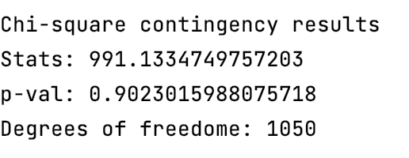

(Note: *Selected days are removed that represent outliers, such as holidays or special events. 1 day in total was identified as an outliers and removed*)

**RQ4**: Has the total number of BART riders decreased in recent years?

$$H_{0}4: B_{1}=0$$

$$H_{A}4: B_{1}<0$$

The last hypothesis to consider is if the total ridership has been increasing, decreasing or staying relatively the same over the last decade. Looking at the total span from 2010 to present in figure 18 shows total rider for each month.

Figure 18

Total Riders averaged per month from 2011 to 2021



There appears a slight upward trend, then about 2017 time frame, a subtle downward trend. However, in 2020, with the Covid-19 pandemic, ridership drastically falls in 2020. To look closer and focus on the last few years, the Covid-19 period is removed the data is focused between 2016 and 2019 and shown in Figure 19.

Total BART riders each month does appear to decline at close to 2017 and continue downward. However, it is subtle. To test the hypothesis that ridership is declining, a linear regression is applied and the slope is tested against a negative correlation with riders vs. months.

Figure 19

Total riders averaged per month from 2016 to 2019 with regression line



Figure 20

Linear Regression results for monthly average riders



A regression gives a P-value of 0.001 in figure 17, which rejects the NULL hypothesis that ridership has remained steady and concludes that ridership has decreased over the last three to four years.

# **Result Summary**

The results show that riders do commute in repeatable patterns. Riders are shown to travel in repeatable patterns based on the day of week and hour of day. Riders at Concord Station at 7:00AM on Monday for example, travel to the same destinations each Monday in the same proportions. Conversely, riders arrive at those stations in predictable and repeatable proportions. These results were demonstrated using high volume routes in the morning commute during the most congested hours between 7:00 and 800:AM.

While not shown, is it also important to note that high volume stations (Concord and 19th Street) were used and purposely selected based on their ridership levels. It is very likely that there are other stations that do not have the same repeat riders following the same commutes each day. Smaller, less used stations are likely more random in nature and may not be good candidates for route models.

# **Limitations**

One immediate limitation is the number of routes to consider. To facilitate reasonable exploration early, only a subset of routes is considered at first. This is due to extremely high number of routes possible. Another limitation is the data granularity. The RRD is bucketized at one hour. While normally, this would be considered high fidelity data, it does summarize the data into only single hours of total riders which does introduce some errors when synthesizing or joining route data with schedule data.

Covid-19 presents a complication with normal rider data. After the pandemic hit the Bay Area, BART ridership drastically decreased and schedules and availability were reduced. This could throw off the hypothesis or purpose of the study so Covid-19 months are excluded from the study. This creates a limitation, or a possible one. The study is focused on determining if riders travel in patterned routes. It is entirely possible that the same route patterns still exist during Covid-19 periods. In fact, this would only strengthen the study, showing route patterns are more resilient than expected. However, it is possible that Covid-19 data is removed or treated separately in this study than pre-Covid ridership numbers.

# **Ethical Considerations**

All data used in the study is acquired from BART directly through the Open Data Initiative. There is an assumption here that the data has been carefully scrubbed for any personal details or other privacy details embedded in rider data. Still, an abundance of caution and attention is made to ensure any details that might has gone unnoticed are not exposed in this study. Anything to the contrary will be made known to BART authorities.

There is always a concern how somebody may use this data in a negative way. This is probably always the case with any research. Somebody can use the results for wrong-doing. This study focuses (or attempts to) on the good or positive outcomes possible through better understanding of rider commute routes and station utilization. Ideally, this, if anything at all, will encourage end users to focus on these positive potentials.

***Conflict of Interest***

This study does represent a small conflict of interest in that the author uses the subway system as the primary means of personal transportation. There is a natural desire to keep the subways improving, so there could be a bias towards seeking those results.

# **Literature Review**

Studying subway or light rail usage is an ongoing effort for most major metropolitan cities. One of the best ways towards continual improvement is measuring and studying the current usages and finding new ways to improve based on how riders are using the rails. New stations are added, new cars are added or removed based on rider utilization. Like any business, subways or light rails go through up and down cycles. High crime, poor sanitation, high costs or simply better alternatives can sway commuters to other forms of transportation. While subways and light rails are forms of public transportation usually managed by government authorities, they still face the same competition as any business and must continue to innovate and find new ways to improve services to stay competitive and healthy and reduce congestion (Keler et al., 2020).

One simple way to keep services competitive is timeliness. Late trains, overcrowded stations are often seen as the biggest deterrent from using subways. Riders would rather endure impacted trains than late ones (Kou et al., 2017). Knowing how many riders are entering or queuing in a station can justify more rail cars, increased train frequency or other ways to keep riders on time.

Another problem with overcrowding is reduced sanitation and health concerns. As the number of riders entering or leaving a station grows, so do the health and environmental conditions for that station. Air quality can quickly degrade with increased riders (Xu & Hao, 2017). Riders are likely to avoid subways for fear and concern of viral transmissions such as Covid-19 transmission (Tan & Ma, 2020) and use other forms, such as private car to get. BART authorities want to keep crowd sizes down, and station queues as short as possible to reduce transmissions and understanding the number of riders expected at a station at different times of the day can help ensure proper health and safety protocols are in used. It is very likely viral transmissions of Covid-19 will remain a serious concern for many riders and could adversely affect ridership moving forward. Keeping BART stations clean, well sanitized is likely to be a top priority for riders and authorities together.

While BART is a governmental project, it operates like any profit and loss business. BART must continue to look for new ways to increase revenues. Targeted ads are one such way. Knowing how many riders are entering and leaving a given station on given day and hour and, even more important, where those riders are coming from and departing to, provides an opportunity for local business to advertise to a very targeted group of commuters (Ketelaar et al., 2018). Local business could target ads that are highly sensitive to the estimated number of riders who will be visiting or passing by their place of business at any day or hour (Vukasović, 2020). For example, a coffee shop could present advertisements at the origin station, knowing the number of riders heading towards their shop, and continue ads on the commute to further encourage customers to stop by and purchase a cup of coffee.

Offering “at station” and “on train” advertisements can be an improvement over traditional billboard advertisements that often distract drivers (Belyusar et al., 2016). It is shown that consumers in a crowded subway or station are, surprisingly, twice as likely to respond to advertisement than in in non-crowded cases (Andrews et al., 2016). This can present a great opportunity for local businesses to target stations with large volumes of riders passing through.

Finally, and importantly, BART is an extremely environmentally positive transportation service. It is estimated that each commuter, in comparison to a private vehicle, the equivalent of 224 miles per gallon on average and up to 422 miles per gallon during peak times (*Sustainability*, n.d.). Many countries and cities are transitioning from increasing road-based commutes to rail based to improve quality of life and reduce emissions all at the same time (Ćetković et al., 2020). The more riders are aware of the positive impact they are having by using public transportation services, perhaps the more encouraged riders will feel to continue using such an innovative service and experience the joy and stress-free commutes of public transportation (Ercan et al., 2016).

# **Future**

One limitation of this study, is Covid-19 effects. The purpose of this study is to look at the pattens riders take each day, and if those patterns are repeatable. It is likely data would need to be separated between pre and post Covid-19 periods. As BART schedules were changed and train availability was drastically reduced during Covid19, it is very possible that route patterns remained unchanged. This would only strengthen this research if accurate. Currently, this is not a hypothesis test in this study.

If riders are shown in this study to commute is consistent routes each day, it would be very interesting to see how those patterns are similar or changed during Covid-19 periods. Did riders still use the same commutes, just drastically reduced in numbers? How were riders affected?

**Conclusion**

While many subway and public transportation studies focus on the number of riders entering and exiting stations, few look at the ridership route distributions patterns. The distribution patterns tell us where the proportion of riders are heading each morning. Armed with this information, local businesses, riders and BART itself can offer improved services and increase the quality of riders’ commute each day.

The results show that riders are dependent on the time of day and day of week and riders commute in repeatable routes to their destinations. Riders departing and arriving at select stations, come from the same population of commuters. The results show that both departing and arriving trains have consistent proportions of riders from fixed stations.

This is a remarkable result. Local business can advertise or promote goods and services to a very specific and predictable set of riders.

# References

Andrews, M., Luo, X., Fang, Z., & Ghose, A. (2016). Mobile ad effectiveness: Hyper-contextual targeting with crowdedness. *Marketing Science*, *35*(2), 218–233.

Belyusar, D., Reimer, B., Mehler, B., & Coughlin, J. F. (2016). A field study on the effects of digital billboards on glance behavior during highway driving. *Accident; Analysis and Prevention*, *88*, 88–96.

Ćetković, J., Lakić, S., Bogdanović, P., Vujadinović, R., & Žarković, M. (2020). Assessing environmental benefits from investment in railway infrastructure. *Polish Journal of Environmental Studies*. https://doi.org/10.15244/pjoes/109849

Ercan, T., Onat, N. C., & Tatari, O. (2016). Investigating carbon footprint reduction potential of public transportation in United States: A system dynamics approach. *Journal of Cleaner Production*, *133*, 1260–1276.

Ketelaar, P. E., Bernritter, S. F., van Woudenberg, T. J., Rozendaal, E., Konig, R. P., Hühn, A. E., Van Gisbergen, M. S., & Janssen, L. (2018). “Opening” location-based mobile ads: How openness and location congruency of location-based ads weaken negative effects of intrusiveness on brand choice. *Journal of Business Research*, *91*, 277–285.

Kou, W., Chen, X., Yu, L., Qi, Y., & Wang, Y. (2017). Urban commuters’ valuation of travel time reliability based on stated preference survey: A case study of Beijing. *Transportation Research. Part A, Policy and Practice*, *95*, 372–380.

*Sustainability*. (n.d.). Bart.Gov. Retrieved April 18, 2021, from https://www.bart.gov/about/projects/cars/sustainability

Tan, L., & Ma, C. (2020). Choice behavior of commuters’ rail transit mode during the COVID-19 pandemic based on logistic model. *Journal of Traffic and Transportation Engineering (English Edition)*. https://doi.org/10.1016/j.jtte.2020.07.002

Vukasović, T. (2020). Understanding the consumers’ personal characteristics as the starting point for targeted marketing. *Management*, *15*(1), 29–41.

Wang, X., Rodríguez, D. A., Sarmiento, O. L., & Guaje, O. (2019). Commute patterns and depression: Evidence from eleven Latin American cities. *Journal of Transport & Health*, *14*(100607), 100607.

Xu, B., & Hao, J. (2017). Air quality inside subway metro indoor environment worldwide: A review. *Environment International*, *107*, 33–46.